Aws Vpc challenges

- Design and deploy a scalable network architecture using AWS Transit Gateway to simplify network connectivity between multiple VPCs.
- Step 1: created three vpc’s in aws console and named it vpc1, vpc2, vpc3.
- Gave them different cidr Id’s or else it overlaps when we one to other.
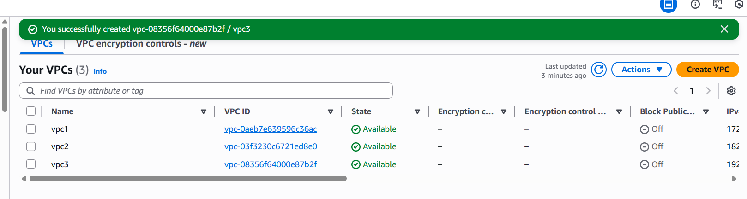
- Created three subnets sb01, sb02, sb03.
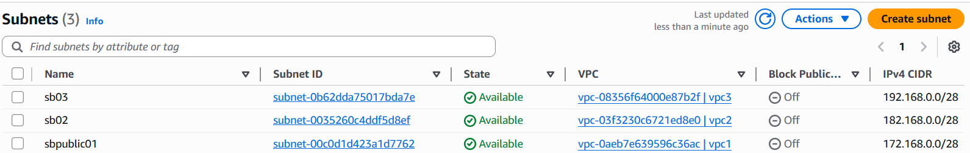
- Created three route tables rt01, rt02, rt03. Added respective subnets to routes in subnet associations.
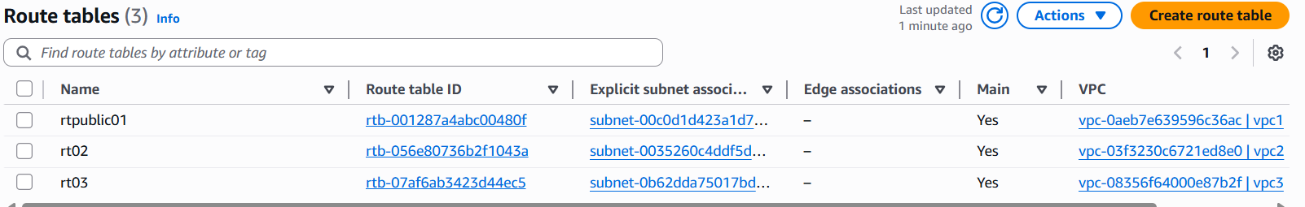
- Created three internet gateways igw01, igw02, igw03. And attached them to their respective vpc’s.
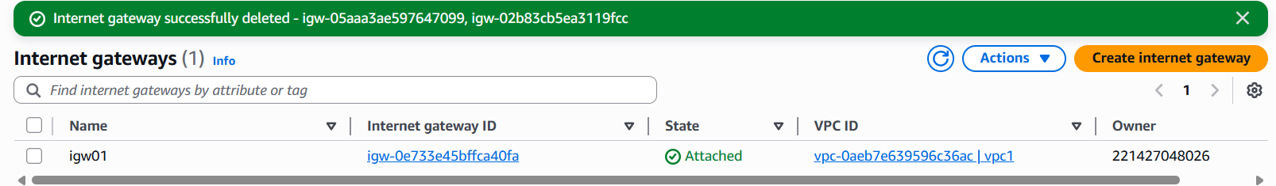
- Went back to route tables select rt > edit routes > add route > select internet gateways and enter respective igw Id which is created using vpc Id > save changes. Repeat the process for remaining two route tables as well as we can see in the below screenshot
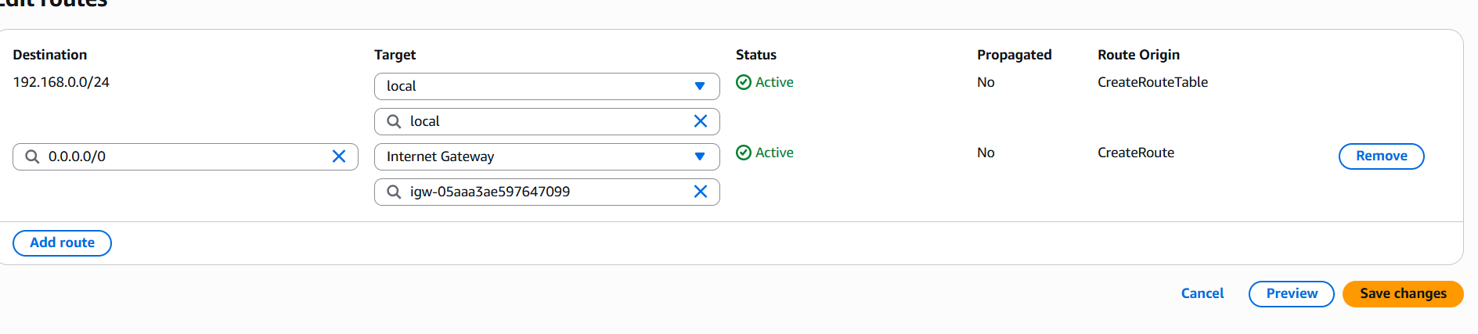
- Transit gateway is created tqmain. Once created we can see status available below the state
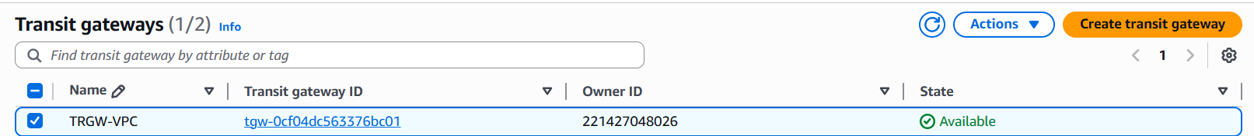
- Let’s create Transit gateway attachments > create Transit gateway attachment > give name tag > select a transit gateway Id which we created before > attachment type select vpc > select a vpc Id > click on create transit gateway attachment. It’s created successfully.
- Repeat this same process for remaining two vpc’s.
- Transit gateway attachment has been created tqa01, tga02, tga03. Once created we can see status available in below the state
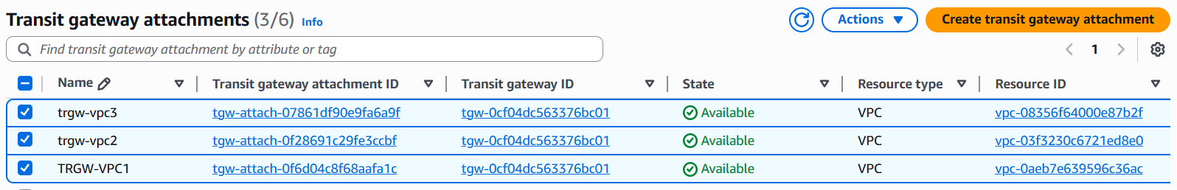
- Again, back to route tables > select rt01 > edit routes > add route > select transit gateway in target > enter vpc02 CIDR ID in destination > add route > select transit gateway in target > enter vpc03 CIDR ID in destination. Repeat same process for remaining two route tables.
- As we can see below screenshot that route permissions for public subnet
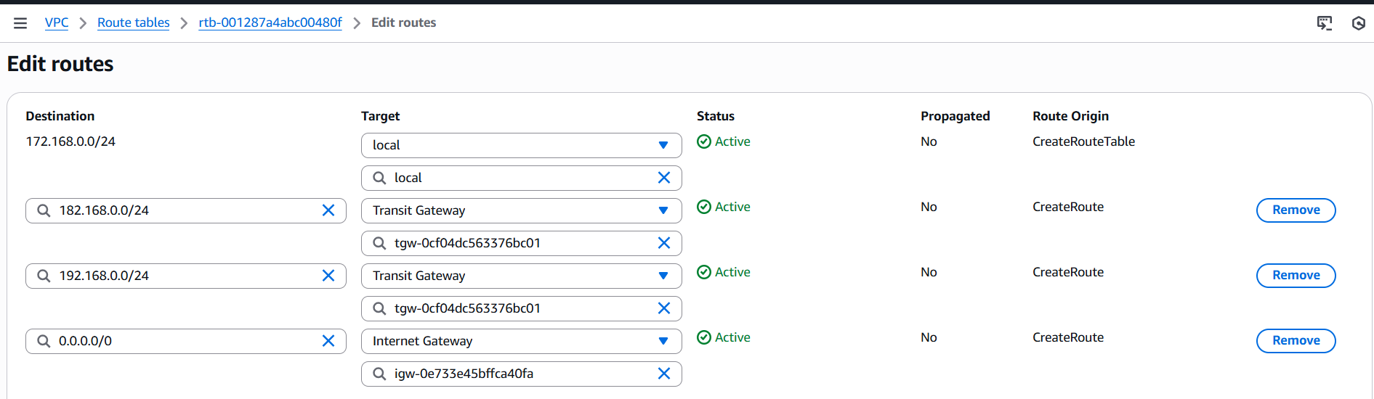
- As we can see below screenshot that route permissions for private subnet
- Repeated same for other route tables
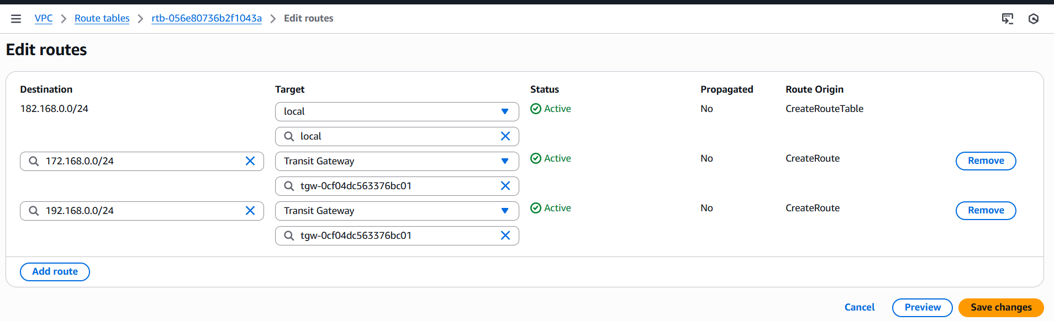
- Created three instances vpc1-ec2, vpc2-ec2, vpc3-ec2
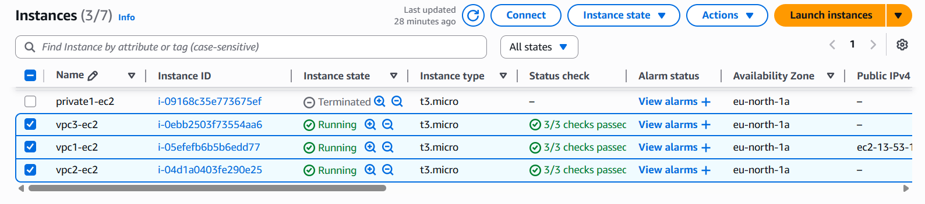
- Connect with public vpc and go to git bash, once connected ping (enter private Ip address of vpc 2)
- As we can see below screenshot that ping is working.
- Repeat the same process for other vps’s.
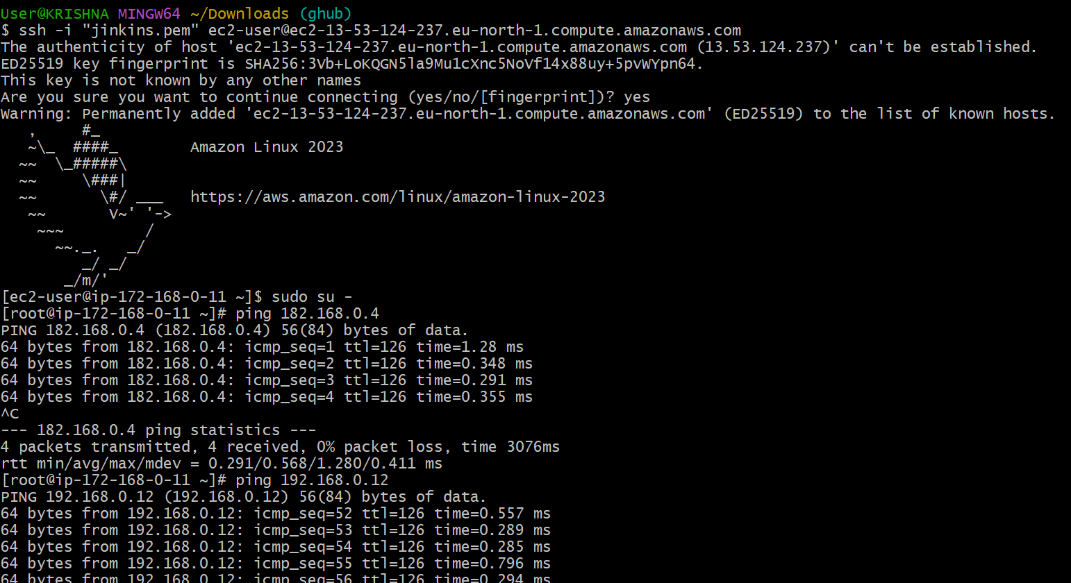
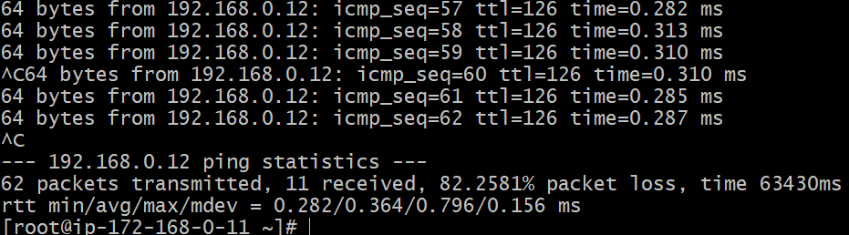

- Configure VPC endpoints to securely access AWS services without internet gateways or NAT gateways, ensuring data privacy and minimizing exposure to external threats.
- Endpoints
- Create two vpc, subnets, internet gateways, route tables
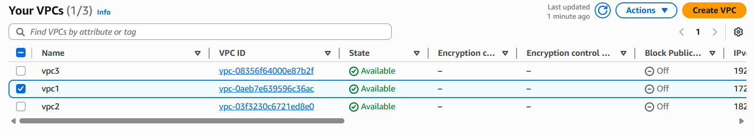
- Created four subnets one public and remaining three private subnets
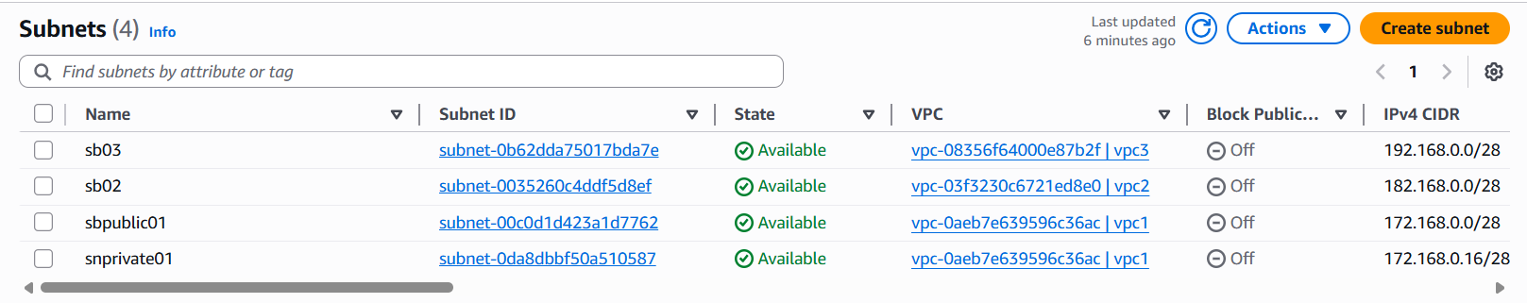
- Created four route tables one public and remaining three private route tables
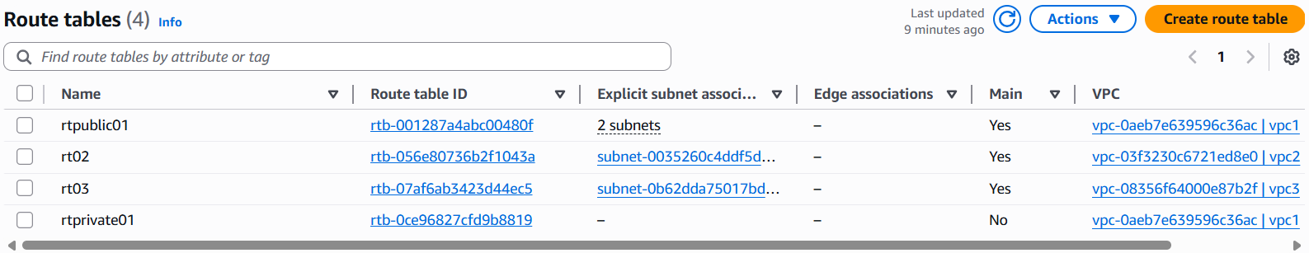
- Select end points > gave name endpointq5 > type Aws services > in service search for s3 and select. > select vpc in network settings > Additional settings select enable private DNS name > select subnets > select default security groups > In policy select full access > click on create endpoint.

- if it shows available in status then it is created successfully.

- Using aws configure, configured newly created access key, secret access.
- Create an new file copy paste the pem key here, give permissions and execute
- Using aws configure and enter access key > secret access key > region > json.
- Validation: As we can see in the below screenshot that s3 bucket has been created.
